**OBJECT ORIENTED PROGRAMMING LAB**

**Name: Jomol R.K**

**Roll No:09**

**Batch: S2 MCA B**

**Date:30/05/2022**

**Experiment No.: 17**

**Aim**

**Program to list the sub directories and files in a given directory and also search for a file name.**

**Procedure**

import java.io.File;

import java.io.*;

import java.util.*;

public class P1 {

public static final String RESET = "\033[0m";

public static final String RED = "\033[0;31m";

public static final String TEXT_RESET = "\u001B[0m";

public static final String TEXT_BLACK = "\u001B[30m";

public static final String TEXT_RED = "\u001B[31m";

static void RecursivePrint(File[] arr, int index, int level, String searchfor) {

if (index == arr.length)

return;

for (int i = 0; i < level; i++)

System.out.print("\t");

if (arr[index].getName().toLowerCase().contains(searchfor))

System.out.print(TEXT_RED);

else

System.out.print(RESET);

if (arr[index].isFile())

System.out.println(arr[index].getName());

else if (arr[index].isDirectory()) {

System.out.println("[" + arr[index].getName() + "]");

RecursivePrint(arr[index].listFiles(), 0, level + 1, searchfor);

}

RecursivePrint(arr, ++index, level, searchfor);

}

public static void main(String[] args) {

Scanner scan = new Scanner(System.in);

System.out.println("Enter the directory path");

String maindirpath = scan.nextLine();

System.out.println("Enter the file/directory name to search");

String searchfor = scan.nextLine();

File maindir = new File(maindirpath);

if (maindir.exists() && maindir.isDirectory()) {

File arr[] = maindir.listFiles();

System.out.println("#################################################");

System.out.println("Files from main directory" + maindir);

System.out.println("#################################################");

RecursivePrint(arr, 0, 0, searchfor.toLowerCase()); // array,index,level,search

}

}

}

**Output Screenshot**

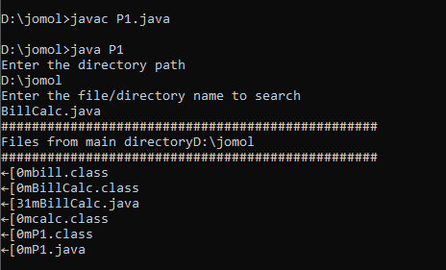

**Experiment No.: 18**

**Aim**

**Write a program to write to a file, then read from the file and display the contents on the console.**

**Procedure**

import java.io.FileReader;

import java.io.FileWriter;

import java.io.IOException;

import java.io.*;

import java.util.*;

import java.io.File;

class Read {

public static void main(String[] args) {

String var = "";

Scanner scan = new Scanner(System.in);

System.out.println("Enter the text to create file : type ENTER key 3 times to stop");

while (!var.endsWith("\n\n\n"))

var = var + scan.nextLine() + "\n";

try {

File file = new File("output.txt");

FileWriter fw = new FileWriter(file);

fw.write(var);

fw.close();

System.out.println("Reading File content");

FileReader fr = new FileReader("output.txt");

String str = "";

int i;

while ((i = fr.read()) != -1) {

str += (char) i;

}

System.out.println(str);

fr.close();

} catch (IOException e) {

System.out.println("There are some exception");

}

}

}

**Output Screenshot**

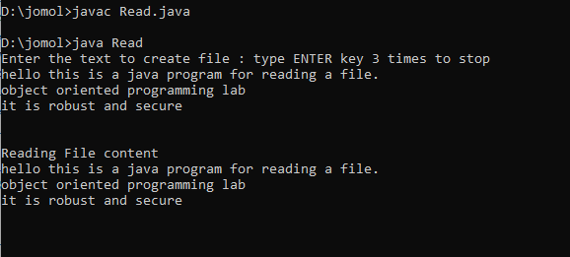

**Experiment No.: 19**

**Aim**

**Write a program to copy one file to another**

**Procedure**

import java.io.FileReader;

import java.io.FileWriter;

import java.io.IOException;

import java.io.*;

import java.util.*;

import java.io.File;

public class Copy {

public static void main(String[] args) {

Scanner scan=new Scanner(System.in);

System.out.println("Enter the source File Name");

String source=scan.nextLine();

try {

FileReader fr=new FileReader(source);

String str = "";

int i;

System.out.println("Reading from file "+source);

while ((i = fr.read()) != -1) {

str += (char) i;

}

System.out.println(str);

System.out.println("\n Enter the filename to copy");

String destination=scan.nextLine();

File file=new File(destination);

FileWriter fw = new FileWriter(file);

fw.write(str);

fr.close();

fw.close();

System.out.println("Copied from "+source+" to "+destination+ " Successfully..!");

} catch (Exception e) {

System.out.println("Exception Occured");

}

}

}

**Output Screenshot**

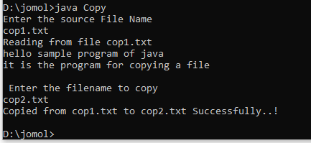

**Experiment No.: 20**

**Aim**

**Write a program that reads from a file having integers. Copy even numbers and odd numbers to separate files.**

**Procedure**

import java.io.FileReader;

import java.io.FileWriter;

import java.io.IOException;

import java.io.*;

import java.util.*;

import java.io.File;

public class oddeven {

public static void main(String[] args) {

try {

FileReader fr = new FileReader("numbers.txt");

BufferedReader br = new BufferedReader(fr);

File file1 = new File("oddnumbers.txt");

FileWriter fw1 = new FileWriter(file1);

File file2 = new File("evennumbers.txt");

FileWriter fw2 = new FileWriter(file2);

String num;

while ((num = br.readLine()) != null) {

if (Integer.parseInt(num) % 2 == 0) {

fw2.write(num + "\n");

}

else {

fw1.write(num + "\n");

}

}

fw1.close();

fw2.close();

}

catch (Exception e)

{

System.out.println("Error");

}

}

}

**Output Screenshot**



